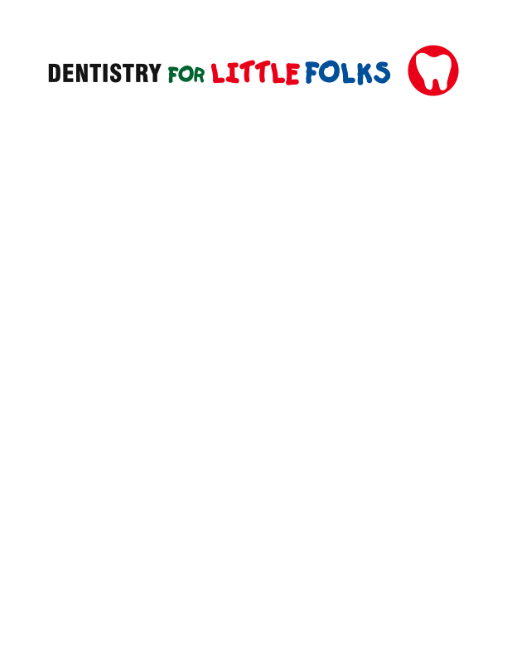

Dr. Jennifer Ochoa Dr. Nelly Gonzalez
Consent for Conscious Sedation
I hereby authorize Dr. Jennifer Ochoa/Dr. Nelly Gonzalez to perform the necessary dental treatment on my child under oral conscious sedation. I understand that my child is unable to be treated using the usual/customary dental techniques due to their young age, fear/anxiety, or their inability to cooperate for dental treatment . I understand that not all conscious sedations are successful, and if the conscious sedation fails, we will need to discuss alternative ways to complete the dental treatment, like general anesthesia. It may be necessary for the assistant(s) to hold the patient’s hands, stabilize the head and/or control leg movements. On some occasions, multiple sedation appointments may be necessary to complete all the dental treatment required.
I fully understand that possible complications may include nausea, vomiting, allergic reactions, fluctuations in breathing pattern, heart rhythm and/or blood pressure; and although extremely unlikely, brain damage and death. I further authorize Dr. Jennifer Ochoa/Dr. Nelly Gonzalez to perform necessary procedures to preserve the health and safety of my child. Nitrous oxide will also be utilized to complement and increase the efficacy of the oral sedatives, as well as local anesthesia to help control pain.
I have read carefully and understand the information provided, and I have had all my questions about the sedation, its risks and side effects, answered to my satisfaction. I understand and have been given a copy of the pre-sedation and post-sedation instructions.
I understand that a $150 fee will be collected at the time of scheduling. This fee will be used towards the treatment needs and is non refundable if the appointment is canceled less than 48 hours prior.
I do give my free and voluntary informed consent to the treatment.

______________________________ ___________________
Parent/Guardian Signature Date

